OPTITEX:  
RAW FABRIC MEASUREMENTS JSON





Contents

1. Change history 3

2. Introduction 3

3. Fabric Testing 3

3.1. Thickness 3

3.2. Weight per Unit Area 4

3.3. Bending 4

3.4. Stretch 6

3.5. Friction 9

4. JSON format description 9

4.1. Units 9

4.2. Thickness 9

4.3. Weight 10

4.4. Bending 11

4.5. Stretch 14

4.6. Friction 17

4.7. JSON Example 17

5. Format compatibility and conversion 21

5.1. Stretch data compatibility 21

5.2. Bending data compatibility 22

# Change history

|  |  |  |  |
| --- | --- | --- | --- |
| Date | Version | Author | Details |
| 4/5/20 | 1 | Tseytlin A. | Initial creation of doc |
| 11/2/20 | 2 | Tseytlin A. | Bending and Stretch structure changed to allow multiple measurement series. |

# Introduction

To leverage the U3M format as a container providing users with comprehensive fabric definition including both physical and visual properties, it is necessary to implement a JSON-based format compatible with Optitex method of fabric testing. Such a format should provide you with the possibility to handle the raw measurement data acquired in the result of testing.

From Optitex perspective, existing of such raw measurement data within U3M file will allow to perform a calculation of physical properties necessary for the fabric definition and simulation.

# Fabric Testing

The fabric testing scheme utilized by Optitex consists of series of separate tests intended to perform raw data measurement and corresponding calculation of such physical properties as:

* Thickness
* Weight per Unit Area
* Bending (in both warp and weft directions)
* Stretch (in warp, weft and bias directions)

In addition to properties mentioned above, the friction property is empirically assigned.

## Thickness

The thickness testing is performed using the digital fabric thickness gauge.

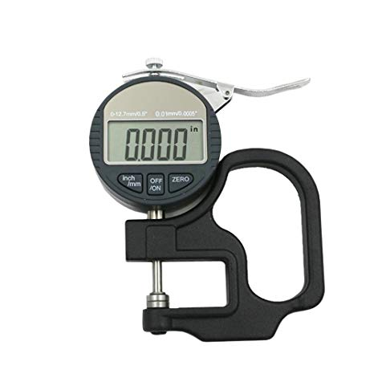

The measurement is performed in compliance with industry common practice and the ASTM D1777 - 96(2015) standard. Such a thickness measurement provided by the digital thickness gauge yields sufficient results for fabric simulation purposes.

The raw measurement data provides you with the demandable thickness value (see topic ‎4.1) with no additional calculation.

## Weight per Unit Area

The weight per unit area testing is performed using the high precision digital scale.

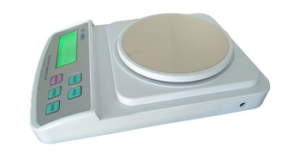

It is recommended to perform measurement of circular specimen cut with the GSM Cutter, allowing cutting an uniform circular fabric specimen without measuring.

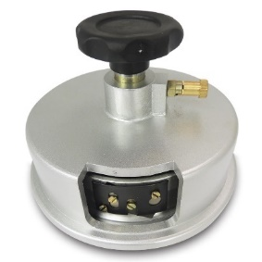

|  |  |
| --- | --- |
|  | Typically, the size of specimen cut using a GSM cutter is described by area (cm2). |

Once the specimen is cut, the weighment is performed, providing you with the raw weight of the specimen. The measured raw data is utilized to perform the calculation of the demanded value of Weight per Unit Area is calculated according to the following formula:.

$$Weight per Unit Area= \frac{{10}^{4}*Weight}{Area}$$

The resulted Weight per Unit Area appears using g/m2 units.

In addition to the recommended method of the circular specimen weighment, it is also possible to perform the testing of a rectangular specimen.

## Bending

The performance of any textile structure under most service conditions depends to a great extent on its bending behavior. The importance of the bending behavior is apparent in the folding of sleeping bags or the billowing of tents or for the apparels in the parts like knee, elbow, sleeves etc. In other words, the bending occurs in those areas where different forces (by direction as well as by value) are applied to the same area of the product.

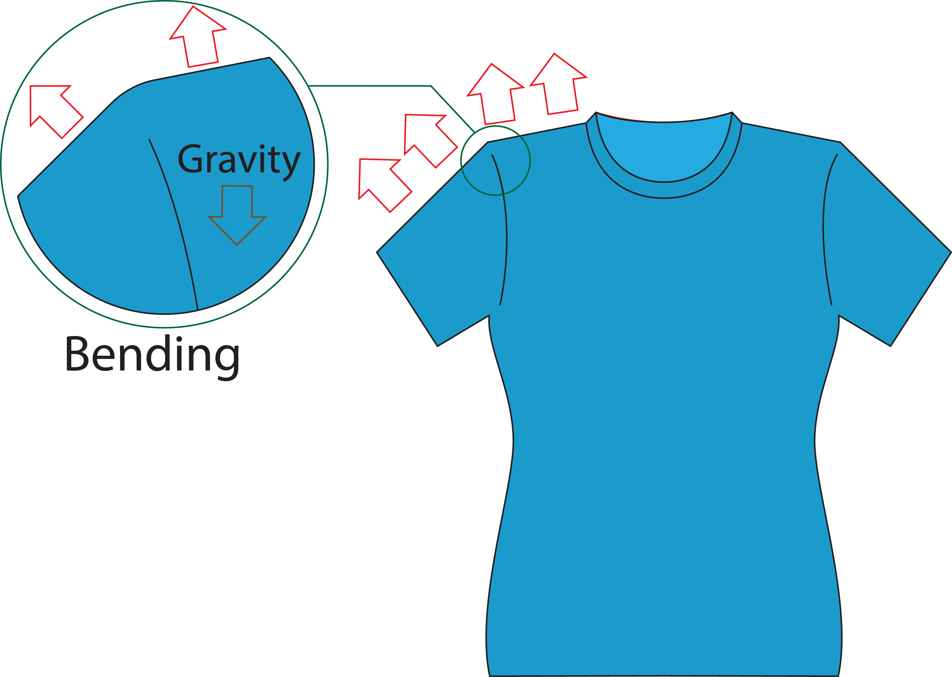

The bending behavior is expressed in terms of bending rigidity (also known as flexural rigidity) which provides you with a measure of ease with which the fabric bends. The fabrics flexural rigidity basically depends on the constituent fibers and yarns from which the fabric is manufactured, the fabric construction and most importantly the nature of the chemical treatment given to the fabric.

In Optitex, the testing of flexural rigidity is performed using the cantilever test in compliance with the D1388-18 standard. In general, the testing could be performed using various manual and automatic devices utilizing this principle.

Generally, the cantilever testing device compatible with Optitex, could be implemented by two composition schemes classified by the contact surface orientation; the contact surface could be either inclined or horizontal.

|  |  |
| --- | --- |
| Inclined contact surface | Horizontal contact surface |
|  |  |
| With this scheme, the specimen is moved along the table until the bended end of the specimen touches the inclined surface as shown below. Usually, the inclined surface of fixed angle of 41.5deg is used.  This scheme is implemented in Shirley Stiffness Tester device (and similar) commonly used in industry. | With this composition scheme, the specimen is moved along the table until the bended end of the specimen touches the step - horizontal contact surface located below the table at the specified vertical distance. |
| With the inclined contact surface scheme, the measurement of a single property – bending length (BL) is performed as shown below.  The bending angle (BA) is a property of the testing device which is known and common for all tests performed. | With horizontal contact surface scheme, the measurement is performed to determine two parameters: bending length (BL) and contact distance (CD).  The bending height (BH) is a property of the testing device which is known and common for all tests performed. |

Regardless to the composition scheme of the selected device, the final demanded flexural rigidity is calculated according to the following formula:

$Flexural Rigidity =980*{10}^{-4}*M*{BL }^{3}*\frac{cos\frac{BA}{2}}{8*tan BA}$; dyn*cm,

where

* + M – Weight per unit Area (g/m2)
  + BL – Bending length (cm)
  + BA – Bending Angle (deg), 41.5° for Shirley Stiffness Tester

In a case, when the height/distance composition scheme is utilized, the additional calculation of the bending angle is performed.

$$BA=arctan⁡\frac{BH}{CD}$$

In order to maintain acceptable results consistency, the series of measurements is performed for different specimens with the following calculation of average result.

In Optitex, the automated XHF-42AII fabric stiffness tester is used to provide you with the precise, accurate and yet consistent measurements of bending property (i.e., fabric stiffness or flexural rigidity).

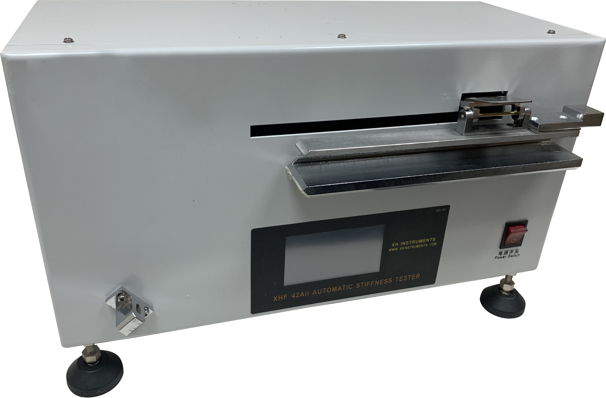

## Stretch

**Stretching** is one of material deformation types most relevant for fabrics. In Optitex, the fabric behavior while stretching is described utilizing a regular elastic theory.

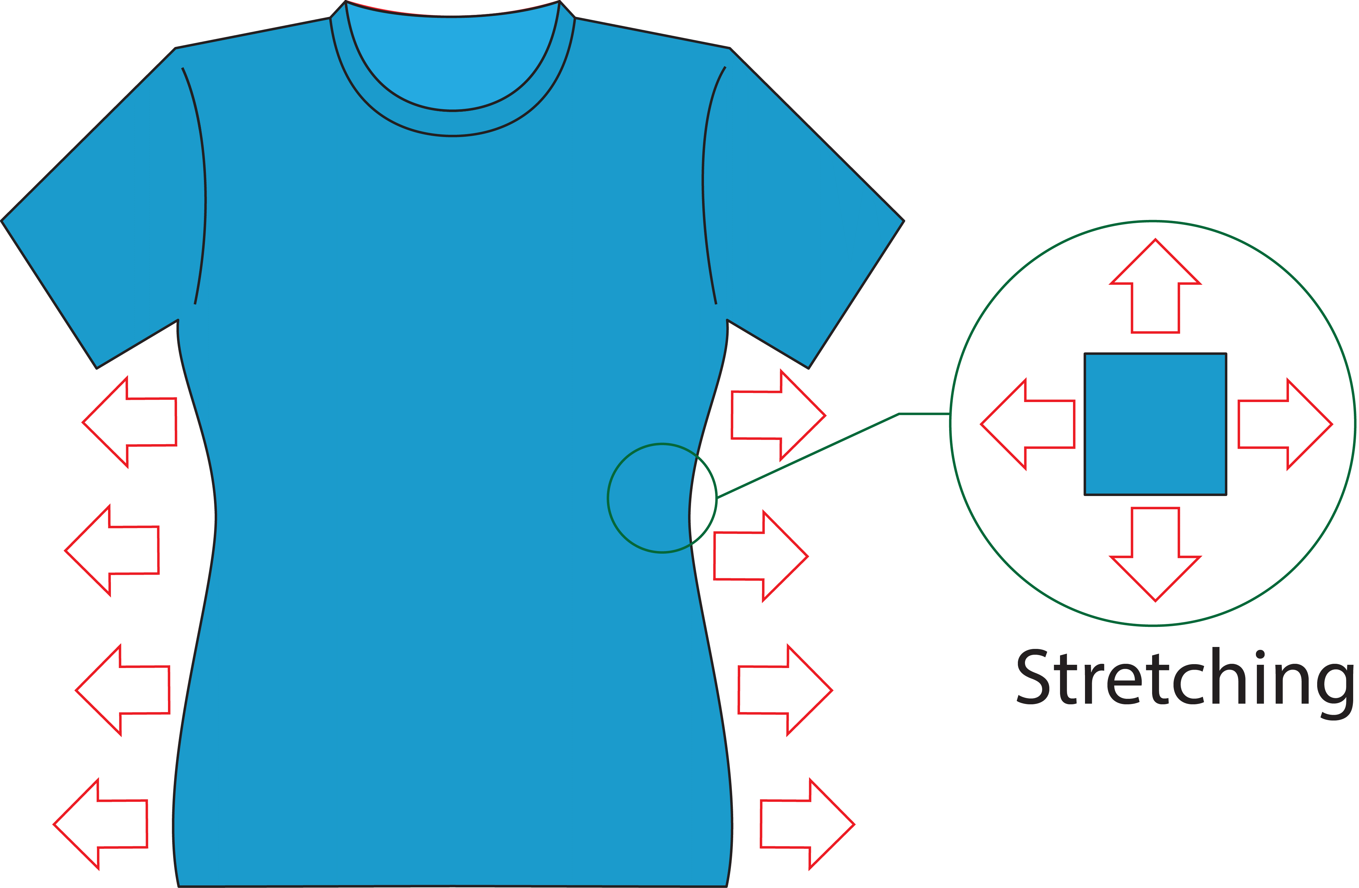

According to the elastic theory, applying of various external stretching forces to a fabric causes appearance of **Stress**, which could be described as a physical quantity that expresses the internal forces that neighboring particles of a continuous material exert on each other. **Strain** or **elongation** provide you with the measure of the deformation of the fabric caused by stress described above.

The fabric behavior while a load is applied could be described by the by the regular stress-strain curve, where the vertical axis provides you with the value of stress and horizontal axis provides you with the corresponding value of strain.

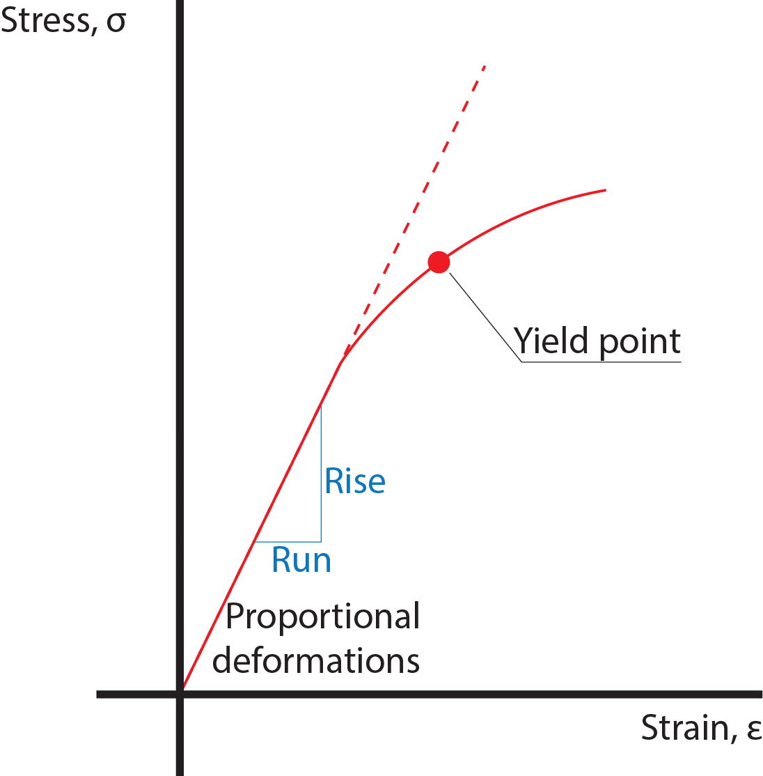

Once the force is applied to the specimen and deformation starts, the stress-strain curve is linear. The linear segment of the curve refers to the stage of **proportional deformation**. Proportional deformations typically most relevant in fashion and garment production world, since typical loads naturally applied to fabrics during regular wearing are relatively low. While the load is continued, the stress-strain dependency becomes non-linear.

Once deformations experienced by the fabric belong to the proportional deformation stage, the fabric behavior obeys the general **Hooke's law**, and the slope (see the illustration above) is **Young's modulus**.

In this diagram, the $Young's modulus=Slope=\frac{Rise}{Run}$.

Mathematically, considering formulas provided earlier to stress and strain, Young's modulus *(E)*, can be calculated by dividing the stress ( by σ ( ε ) {\displaystyle \sigma (\varepsilon )} extensional strain ($ε)$:

$$E=\frac{σ}{ε}=\frac{F/W}{ΔL/L_{0}}=\frac{FL_{0}}{WΔL}=\frac{FL_{0}}{W(L-L_{0})}$$

where

$σ$– stress experienced by specimen

$ε$– strain or elongation of the specimen, caused by the force applying

F – the force applied to the specimen

W – width of the specimen

$L_{0}-$ initial specimen length in the relaxed state

$L$– actual specimen length in the stressed state

The Young’s modulus is a mechanical property that measures the **ability to resist uniaxial deformation (stretching)**. More stretchable fabrics provide you with lower values of the Young’s modulus; higher values of the Young’s modulus represent more rigid fabrics.

Optitex utilizes the value of the Young’s modulus to describe the physical properties of the fabric. The Stretch property is defined to warp and weft directions; the Shear property describes the stretching resistance in the bias direction. These properties enable you to simulate the fabric behavior in the realistic manner while various forces are applied to different parts of garment.

The measurement is performed for the rectangular specimen. The specimen width (W) and initial specimen length in the relaxed state ($L_{0}$) also known as rest length are pre-defined before the test.

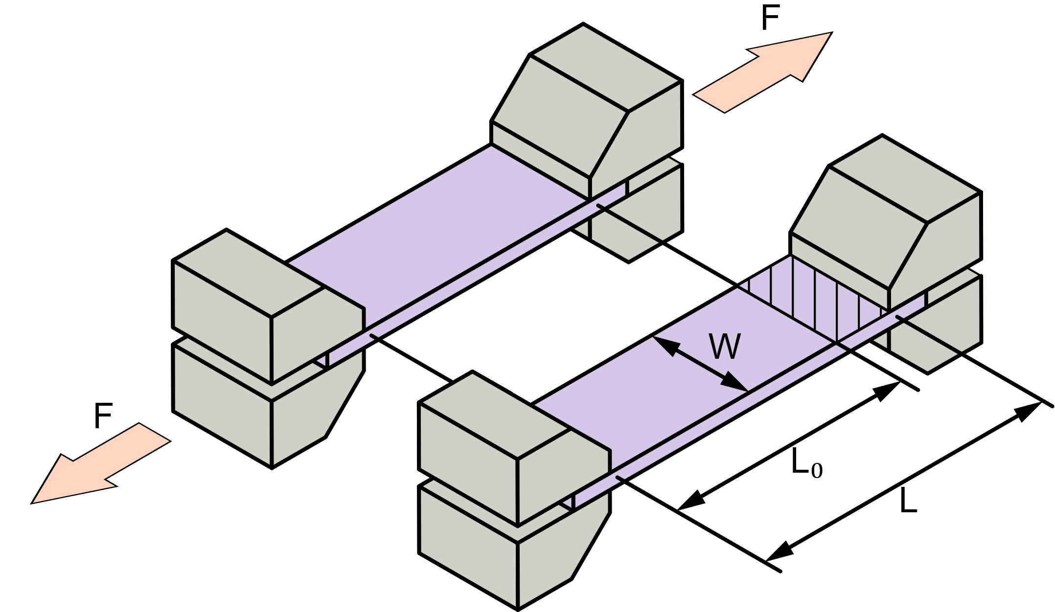

The test raw data is represented by a series of measured force-length pairs providing you with the possibility to build the stress-strain graph as shown.

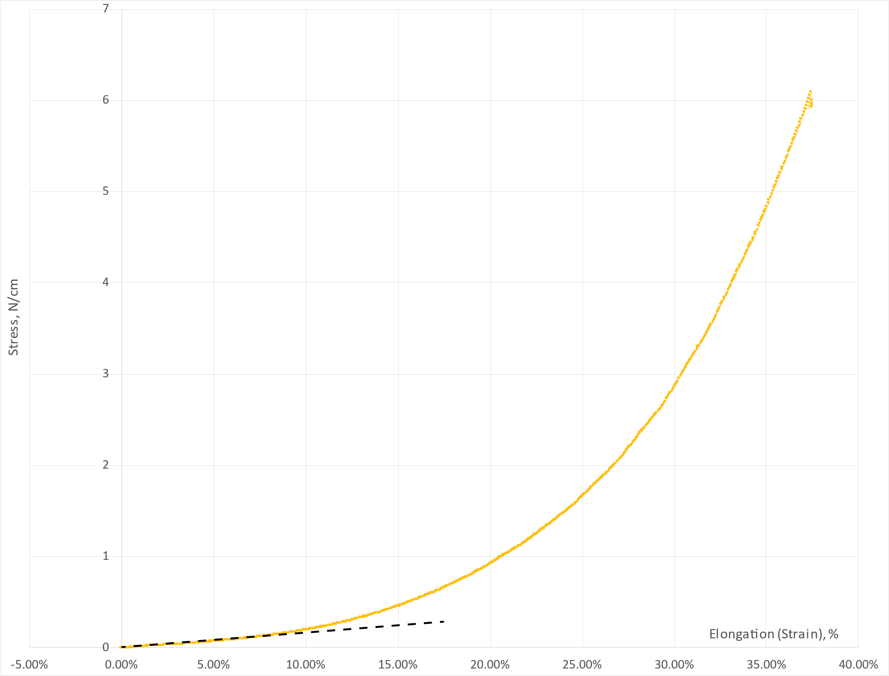

The raw measurement data are further analyzed to calculate the Stretch and Shear properties (Young’s modulus).

## Friction

The friction property of fabric in Optitex is not measured, but empirically assigned. The friction is defined by the coefficient of friction (COF) in the range of 0.05 (smooth and napless fabric) — 0.95 (rough  fabric)

* High value means high resistance to motion on the body and therefor - the fabric will slide less on the body. Higher values of friction describe cases of less sliding fabrics (hard leather, heavy linen, fleece), with a high level of surface roughness.
* Low value means low resistance to motion on the body and therefor - the fabric will slide more on the body. The lower values of the Friction describe cases of better sliding fabrics with the composition based on polyester, viscose, silk and nylon (e.g., silk organza, chiffon and batiste), and with a low level of surface roughness.

Even the friction measurement is not performed, it is still considered as raw measurement data, since this property allows you to accomplish the fabric definition.

# JSON format description

The proposed JSON format provides you with the top-level *physical_properties_raw_data* object containing underlying objects of *thickness*, *weight*, *bending*, *stretch* and *friction* intended to handle the respective raw measurement data. These underlying objects contain regular key-value pair representing a single measurement results or arrays providing you with multiple measurement results.

## Units

Following units are utilized for raw measurement data storing in the JSON format.

|  |  |
| --- | --- |
| *Linear* | All linear measurements like width, length, thickness etc. are provided in **millimeters**; if the source or target software utilizes different units, the conversion is required. |
| *Angular* | All angular dimensions are provided in **degrees**; if the source or target software utilizes different units, the conversion is required. |
| *Weight* | All weight measurements are provided in **grams**; if the source or target software utilizes different units, the conversion is required. |
| *Area* | All area measurements are provided in **sq. centimeters**; if the source or target software utilizes different units, the conversion is required. |
| *Force* | All force measurements are provided in **newtons**; If the source or target software utilizes different units, the conversion is required. |

## Thickness

Example:

*"thickness": 0.2*

The *thickness* object allows you handle the thickness measurement result.

## Weight

Example:

*"weight": {*

*"sample_width":0,*

*"sample_length":0,*

*"sample_area":100,*

*"sample_weight":1.13*

*}*

The *weight* object allows you handle the measurement result for weight per unit area property. The object provides you with following underlying objects:

|  |  |
| --- | --- |
| *sample_width* | In a case when the rectangular specimen is utilized for the weight per unit area testing, the object provides you with the width of the rectangular specimen. If the circular specimen is used, the 0 value should be assigned. |
| *sample_length* | In a case when the rectangular specimen is utilized for the weight per unit area testing, the object provides you with the length of the rectangular specimen. If the circular specimen is used, the 0 value should be assigned. |
| *sample_area* | In a case when the circular specimen is utilized for the weight per unit area testing, the object provides you with the area of the circular specimen (see topic ‎3.2). If the rectangular specimen is used, the 0 value should be assigned. |
| *sample_weight* | This object provides you with an actual measured weight of the specimen (either rectangular or circular). |

In such a way, parameters mentioned above allow you to store within JSON format results of weight measurements performed using either rectangular or circular specimen. In a case of rectangular specimen, the corresponding parameters (*sample_width* and *sample_length*) are defined with nonzero values and the *sample_area* is set to zero. In the opposite case of the circular specimen, the *sample_area* parameter is nonzero; *sample_width* and *sample_length* parameters are set to zero as shown below.

|  |  |
| --- | --- |
| Rectangular specimen | Circular specimen |
| *"weight": {*  *"sample_width":25, "sample_length":180,*  *"sample_area":0,*  *"sample_weight":1.13*  *}* | *"weight": {*  *"sample_width":0,*  *"sample_length":0,*  *"sample_area":100,*  *"sample_weight":1.13*  *}* |

## Bending

Example:

*"bending":[*

*{*

*"direction" : "Warp",*

*"bending_angle" : 41.5,*

*"bending_height" : 0,*

*"data" :*

*[*

*21.1,*

*0*

*]*

*},*

The *bending* array allows you handle the object composed of bending measurement results acquired using cantilever testing method (see topic ‎3.3). The object provides you with following underlying objects:

|  |  |
| --- | --- |
| *direction* | Specify either *Warp* or *Weft* direction of the testing. |
| *bending_angle* | In a case when the cantilever testing is performed using the “inclined table” scheme (see topic ‎3.3), the object’s value provides you with the angle defining the orientation of the inclined table. |
| *bending_height* | In a case when the cantilever testing is performed using the “horizontal table” scheme (see topic ‎3.3), the object’s value provides you with the step between upper and lower tables. |
| *data* | This array allows you to handle a single bending measurement. The array provides you with values as follows:   * First value represents the bending length; * Second value represents contact distance. |

The JSON format mentioned above provides you with the possibility to store the measurement data obtained in the result of both types of cantilever testing: using inclined or horizontal contact surface. In the first case, the meaningful value should be assigned to the *bending_angle* parameter and the *bending_height* value should be set to zero. In the opposite case of the horizonal contact surface, the meaningful value should be assigned to the *bending_height* parameter and the *bending_angle* value should be set to zero. The measurement method affects also the measured data provided within *Samples* arrays. In a case of horizontal contact surface, both bending length and contact distance are measured and specified. In a case of inclined contact surface, only the bending length value should be meaningful; the bending distance value should be set to zero.

The table below illustrates the JSON structure for both types of cantilever test implementation.

|  |  |
| --- | --- |
| Inclined Contact Surface | Horizontal Contact Surface |
| *"bending" : [*  *{*  *"direction": "Warp",*  *"bending_angle": 41.5,*  *"bending_height": 0,*  *"data" :*  *[21.1 , 0]*  *},* | *"bending" : [*  *{*  *"direction": "Warp",*  *"bending_angle": 0,*  *"bending_height": 15,*  *"data" :*  *[21.1 , 12.2]*  *},* |

Such a structure provides you with the possibility to handle a data acquired via unlimited number of tests. The example below, illustrates using the *bending* array for handling multiple tests performed in both Warp and Weft directions.

*"bending":[*

*{*

*"direction":"Warp",*

*"bending_angle":41.5,*

*"bending_height":0,*

*"Data":[*

*21.1,*

*0*

*]*

*},*

*{*

*"direction":"Warp",*

*"bending_angle":41.5,*

*"bending_height":0,*

*"Data":[*

*21.5,*

*0*

*]*

*},*

*{*

*"direction":"Warp",*

*"bending_angle":41.5,*

*"bending_height":0,*

*"Data":[*

*21.3,*

*0*

*]*

*},*

*{*

*"direction":"Weft",*

*"bending_angle":41.5,*

*"bending_height":0,*

*"Data":[*

*21.1,*

*0*

*]*

*},*

*{*

*"direction":"Weft",*

*"bending_angle":41.5,*

*"bending_height":0,*

*"Data":[*

*21.5,*

*0*

*]*

*},*

*{*

*"direction":"Weft",*

*"bending_angle":41.5,*

*"bending_height":0,*

*"Data":[*

*21.3,*

*0*

*]*

*}*

*],*

## Stretch

Example:

*"stretch":[*

*{*

*"direction":"Warp",*

*"initial_length":100,*

*"sample_width":25,*

*"data" : [*

*0,*

*100,*

*0.01,*

*100,*

*0.08,*

*100.2,*

*0.59,*

*100.6,*

*0.89,*

*100.8*

*]*

*}*

*],*

The *stretch* array allows you handle acquired stretch measurement results (see topic ‎3.4). The object provides you with following underlying objects:

|  |  |
| --- | --- |
| *direction* | Specify either *Warp*, *Weft* or *Bias* direction of testing. |
| *initial_length* | This key provides you with the value of the initial length – a length of the extensible part of the specimen located between clamping grips. |
| *sample_width* | This key provides you with the width of the specimen used for the stretch testing. |
| *data* | This array provides you with values of force and corresponding specimen elongation. The array content is composed from multiple value pairs as follows:   * odd values represent the force; the positive value is utilized for the force extending a specimen * even values represent the absolute elongation, i.e. an actual length of the specimen’s part which become elongated. |

Such a structure provides you with the possibility to handle a data acquired via unlimited number of elongation tests. The example below, illustrates using the *stretch* array for handling multiple tests performed in Warp, Weft and Bias directions.

*"stretch":[*

*{*

*"direction":"Warp",*

*"initial_length":100,*

*"sample_width":25,*

*"Data":[*

*0,*

*100,*

*0.01,*

*100,*

*0.08,*

*100.2,*

*0.59,*

*100.6,*

*0.89,*

*100.8*

*]*

*},*

*{*

*"direction":"Warp",*

*"initial_length":100,*

*"sample_width":25,*

*"Data":[*

*0,*

*100,*

*0.01,*

*100,*

*0.08,*

*100.2,*

*0.59,*

*100.6,*

*0.89,*

*100.8*

*]*

*},*

*{*

*"direction":"Weft",*

*"initial_length":100,*

*"sample_width":25,*

*"Data":[*

*0,*

*100,*

*0.01,*

*100,*

*0.08,*

*100.2,*

*0.59,*

*100.6,*

*0.89,*

*100.8*

*]*

*},*

*{*

*"direction":"Weft",*

*"initial_length":100,*

*"sample_width":25,*

*"Data":[*

*0,*

*100,*

*0.01,*

*100,*

*0.08,*

*100.2,*

*0.59,*

*100.6,*

*0.89,*

*100.8*

*]*

*},*

*{*

*"direction":"Bias",*

*"initial_length":100,*

*"sample_width":25,*

*"Data":[*

*0,*

*100,*

*0.01,*

*100,*

*0.08,*

*100.2,*

*0.59,*

*100.6,*

*0.89,*

*100.8*

*]*

*},*

*{*

*"direction":"Bias",*

*"initial_length":100,*

*"sample_width":25,*

*"Data":[*

*0,*

*100,*

*0.01,*

*100,*

*0.08,*

*100.2,*

*0.59,*

*100.6,*

*0.89,*

*100.8*

*]*

*}*

*],*

## Friction

Example:

*"friction": 0.2*

The *friction* object allows you handle the value of coefficient of friction assigned to the fabric. The value is dimensionless.

## JSON Example

*{*

*"physical_properties_raw_data":{*

*"thickness":0.2,*

*"weight":{*

*"sample_width":0,*

*"sample_length":0,*

*"sample_area":100,*

*"sample_weight":1.13*

*},*

*"bending":[*

*{*

*"direction":"Warp",*

*"bending_angle":41.5,*

*"bending_height":0,*

*"Data":[*

*21.1,*

*0*

*]*

*},*

*{*

*"direction":"Warp",*

*"bending_angle":41.5,*

*"bending_height":0,*

*"Data":[*

*21.5,*

*0*

*]*

*},*

*{*

*"direction":"Warp",*

*"bending_angle":41.5,*

*"bending_height":0,*

*"Data":[*

*21.3,*

*0*

*]*

*},*

*{*

*"direction":"Weft",*

*"bending_angle":41.5,*

*"bending_height":0,*

*"Data":[*

*21.1,*

*0*

*]*

*},*

*{*

*"direction":"Weft",*

*"bending_angle":41.5,*

*"bending_height":0,*

*"Data":[*

*21.5,*

*0*

*]*

*},*

*{*

*"direction":"Weft",*

*"bending_angle":41.5,*

*"bending_height":0,*

*"Data":[*

*21.3,*

*0*

*]*

*}*

*],*

*"stretch":[*

*{*

*"direction":"Warp",*

*"initial_length":100,*

*"sample_width":25,*

*"Data":[*

*0,*

*100,*

*0.01,*

*100,*

*0.08,*

*100.2,*

*0.59,*

*100.6,*

*0.89,*

*100.8*

*]*

*},*

*{*

*"direction":"Warp",*

*"initial_length":100,*

*"sample_width":25,*

*"Data":[*

*0,*

*100,*

*0.01,*

*100,*

*0.08,*

*100.2,*

*0.59,*

*100.6,*

*0.89,*

*100.8*

*]*

*},*

*{*

*"direction":"Weft",*

*"initial_length":100,*

*"sample_width":25,*

*"Data":[*

*0,*

*100,*

*0.01,*

*100,*

*0.08,*

*100.2,*

*0.59,*

*100.6,*

*0.89,*

*100.8*

*]*

*},*

*{*

*"direction":"Weft",*

*"initial_length":100,*

*"sample_width":25,*

*"Data":[*

*0,*

*100,*

*0.01,*

*100,*

*0.08,*

*100.2,*

*0.59,*

*100.6,*

*0.89,*

*100.8*

*]*

*},*

*{*

*"direction":"Bias",*

*"initial_length":100,*

*"sample_width":25,*

*"Data":[*

*0,*

*100,*

*0.01,*

*100,*

*0.08,*

*100.2,*

*0.59,*

*100.6,*

*0.89,*

*100.8*

*]*

*},*

*{*

*"direction":"Bias",*

*"initial_length":100,*

*"sample_width":25,*

*"Data":[*

*0,*

*100,*

*0.01,*

*100,*

*0.08,*

*100.2,*

*0.59,*

*100.6,*

*0.89,*

*100.8*

*]*

*}*

*],*

*"friction":0.2*

*}*

*}*

# Format compatibility and conversion

The main purpose of the JSON format described through this document is to provide an unified and standard language sufficient to store raw measurement data provided by all vendors of measurement equipment as well as CAD software. Existing of such an unified language provides you with the raw data compatibility across various CAD systems. Sufficiency of raw measurement data assumes the ability of a certain CAD system to utilize the raw measurement data for the fabric physical properties calculation; the calculated fabric properties are utilized during the simulation.

## Stretch data compatibility

Generally, all CAD system utilize regular stress-strain (force-elongation) raw data in order to perform the calculation of a property describing the fabric stretchability. Such a measurement could be performed using a regular classic dynamometer. In accordance with the specificity of CAD systems, the measurement data set could be composed from single or multiple measurements.

To perform the stretch property calculation:

* Gerber utilizes a single measurement pair of force and elongation,
* CLO3D utilizes five measurement pair of force and elongation,
* Vidia and Optitex utilize CRE (constant-rate-of-load) measurement principle to acquire a measurement data set sufficient to build the stress-strain graph.

The size of the specimen used for the stretch testing varies for every system.

In such a way, the proposed JSON format is considered as sufficient to handle measurement data for all CAD systems mentioned above. However, the JSON format is not compatible with the proprietary measurement method provided by Browzwear (FAB machine). Therefore, further investigation and format matching is required.

Despite the JSON format commanality, the raw measurement data sets acquired by machines provided by various vendors could be different and not sufficient to each other. For example, the CRE-based data sets obtained by Optitex and Vidia measurement methods could be considered as sufficient for CLO3D and Gerber systems. At the same time, a single-value measurement data set acquired by Gerber measurement method is not sufficient for other CAD systems. The table below provides you with the measurement data set compatibility.

|  |  |  |  |  |
| --- | --- | --- | --- | --- |
| **Simulation CAD** | **Measurement CAD** | | | |
| **Gerber** | **CLO3D** | **Vidia** | **Optitex** |
| **Gerber** |  |  |  |  |
| **CLO3D** | — |  |  |  |
| **Vidia** | — | —* |  |  |
| **Optitex** | — | —* |  |  |

(*) – CLO3D measurement method provides you with five force/elongation measurements. These measurements could be limitedly used to build the stress-strain graph used through Optitex and Vidia for stretch ability calculations due to the calculations consistency and accuracy.

## Bending data compatibility

Typically, a measurement of the physical property describing the ability of fabric to bend is measured using the cantilever principle. Vidia, Optitex and Gerber utilize the classic scheme of the cantilever-principled device, where the measurement is performed using a 41.5°-inclined contact surface. CLO3D utilize a bending tester where the measurement is performed with a horizontal contact surface.

The proposed JSON format provides you with the possibility to handle raw measurement data measured using both types of the cantilever devices. However, despite the JSON format compatibility, raw measurement data sets acquired by machines provided by various vendors could be different and not sufficient to each other.

|  |  |  |
| --- | --- | --- |
| **Simulation CAD** | **Cantilever Method** | |
| Horizontal Contact Surface | Inclined Contact Surface |
| CLO3D |  | — |
| Optitex |  |  |
| Gerber | * |  |
| Vidia | * |  |

(*) – the conversion of contact distance and height (acquired at horizontal contact surface machine) into bending angle (typically provided by inclined contact surface machine) could be performed. In such a way, the measured contact distance and height could be considered as sufficient data also for those CAD systems that require bending angle for the calculation of the bending ability. However, the calculation of the contact distance and height based on the measured bending angle cannot be performed. Therefore, the measured bending angle cannot be utilized for CLO3D.